# I_MIM Mission Concept

The main objective of the International Mars Ice Mapper (I-MIM) mission concept is to identify and characterize near-surface water ice reservoirs on Mars. The primary payload, an L-band Synthetic Aperture Radar (SAR), is designed to map mid and low latitudes on the surface of Mars to map these reservoirs, supporting future planning of human missions to Mars.

The reflector that is placed at the end-effector of the space manipulator can also be used to establish telecommunications with Earth’s ground stations. This configuration provides high download data rates. The objective of this exercise is to design a space robotic manipulator that is capable of pointing the reflector towards the Martian surface and to the Earth by keeping the spacecraft body frame nadir pointed (e.g., 𝒁̂𝑺𝑩𝑭 towards the surface). This dual mode is fundamental in supporting the off-nadir pointing of the SAR required to map the ice reservoirs, and to download the data.

# Orbit design

## Objective

The objective of the first part of this exercise is to choose an orbit that is well-suited for the purpose of the I-MIM mission. Considering the coverage required by the mission (map all latitudes included between 25° N/S and 40° N/S), choose a set of orbital parameters that satisfies the science requirements. For the chosen orbit, provide:

1. The semi-major axis 𝑎
2. The eccentricity 𝑒
3. The inclination 𝑖
4. The argument of pericenter 𝜔
5. The right ascension of the ascending node Ω
6. Time series of the spacecraft attitude matrix for nadir pointing
7. (Optional) determine the time required to meet the coverage requirement

## Theoretical approach

## Code implementation

## Results

# Manipulator design

## Objective

The second part is to design a two-link manipulator that enables the science operations of the SAR. The assumed strategy is to collect data for one orbit, and to download data to Earth in the following orbit. Design a manipulator that allows an off-nadir (𝜂=15°) pointing of the array when collecting data, and to point the antenna to the Earth to download the data. The spacecraft attitude must be fixed during these operations. Assume that the AOCS subsystem of the spacecraft keeps the attitude nadir pointed by compensating the torques generated by the manipulator links. Address the following tasks:

1. Model the manipulator by using the Denavit-Hartenberg formulation.
2. Determine the Jacobian and the dynamical equations.
3. By assuming that the manipulator is initially fully stretched (𝜃1 = 𝜃2 = 0), determine the trajectory of the end-effector that enables a constant pointing of the instrument to T (i.e., off-nadir or Earth pointing orientation) from its initial position 𝑃0 to 𝑃𝑓.
4. Determine a control scheme of the manipulator that allows fulfilling the desired trajectory retrieved in point 3, by assuming that the atmospheric drag force is acting on the end-effector (assume that the antenna diameter is 8 m). The atmospheric drag can be computed by retrieving the atmosphere density from http://www-mars.lmd.jussieu.fr/mcd_python/. The drag force can be assumed to be constant.

## Theoretical approach

Parte introduttiva

The manipulator is defined via the Denavit-Hartenberg classical convention; the table XXX resumes its characteristics. The Figure XXX schematically shows the manipulator in a generic pose with its links and rotary joints; the squared plane represents the spacecraft’s face which normal is aligned with the orbit’s one.

|  |  |  |  |  |
| --- | --- | --- | --- | --- |
| DH Table |  | a | d |  |
| Link 1 |  |  |  |  |
| Link 2 |  |  |  |  |

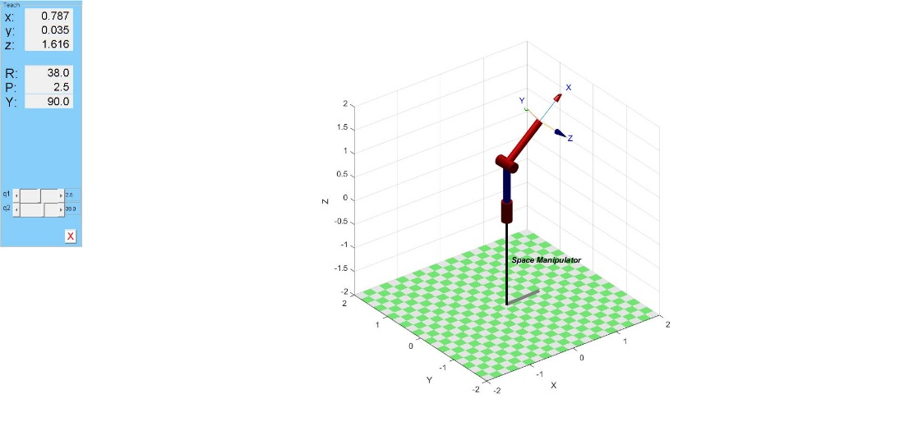

Considering the spacecraft’s central body like a cube of length L = 1 m, the Transformation matrix from the LVLH to the base frame can be defined as shown in eq. XXX. The LVLH frame (Local Vertical Local Horizontal) is located at the cube’s center with the z-axis pointing towards the planet, the y axis is parallel to the spacecraft velocity and the x-axis is to get a right-handed triad. The base frame is located at the center of the spacecraft face that mount the manipulator with the x and y axis lying on it while the z axis is parallel and agree to the first joint rotation axis. The figure XXX shows the s/c with the LVLH and Base frames attached on it.

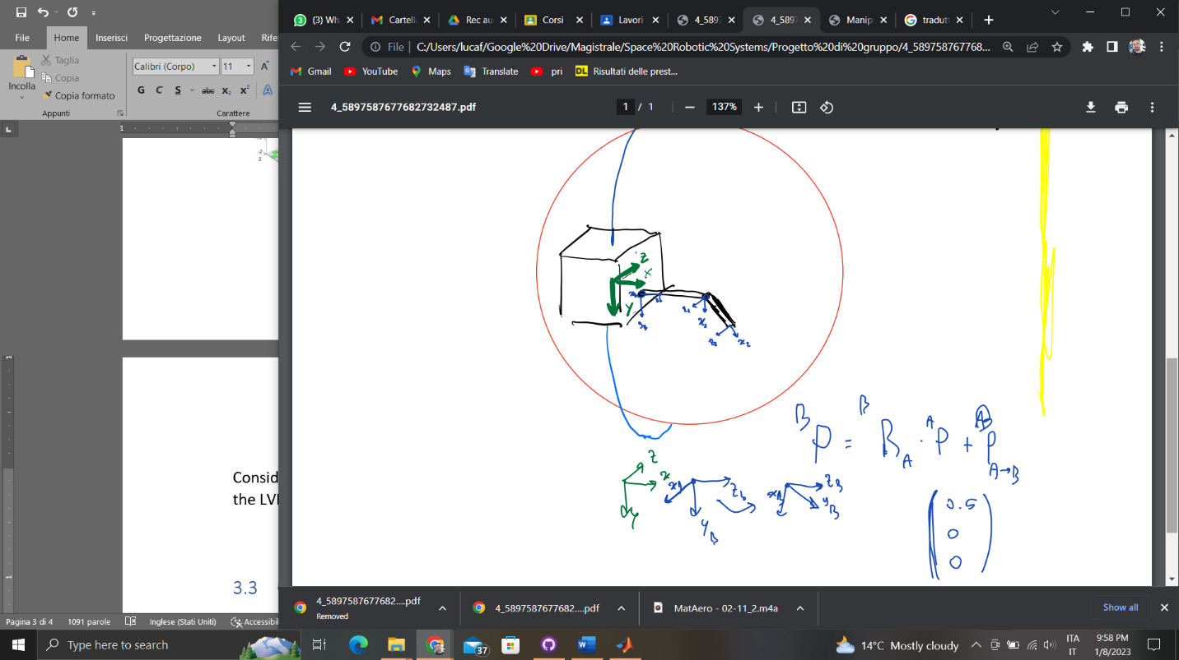

The rotation of 45 deg around the z axis is due to… {famose spiega da Adriano il perché (ha a che fare con le singolarità)}

## Code implementation

## Results

# Virtual manipulator

## Objective

Assuming that the AOCS subsystem does not compensate the torques generated by the manipulator links:

1. Model the virtual manipulator by assuming a spacecraft mass m = 500 kg.
2. Determine the trajectory of the end-effector for the virtual manipulator.

## Theoretical approach

The method, originally proposed by Vafa and Dubowsky[1], introduces the concept of a "Virtual Manipulator" for the modelling of manipulators working in space. It is shown that the implementation of a virtual manipulator and a virtual ground can facilitate the planning and control of the actual manipulator mounted on the spacecraft while simultaneously minimizing the degrading consequences of manipulator/vehicle dynamic interactions.

The virtual ground is an imaginary point, fixed in inertial space, defined as the center of mass of the whole system. If the spacecraft is unaffected by external forces (such as reaction wheels or ACS jets) the position of the virtual ground will remain unchanged in inertial space. Analogously, internal forces given by joint torques or forces will also not move the position of the VG. As such the virtual manipulator is shown[] to have exploitable properties which enables us to model the kinematic and dynamic motion of the free-floating manipulator system by utilizing the simpler virtual manipulator which has a fixed base in inertial space.

In the virtual space, the manipulator gains degrees of freedom related to the position and attitude of the spacecraft. Our system will therefore have 6 + 2 DOF.

The location of the virtual ground is found given the initial configuration of the manipulator system. The position of the center of mass of each link is defined with respect to an inertial reference frame, which in our case is MJ2000 as extracted from the General Mission Analysis Tool (GMAT). Given our 2 link spatial manipulator the total number of links in the VM will therefore be comprised of a spherical joint associated with the spacecraft degrees of freedom and he previously defined 1-DOF links. The VG will be obtained through the following formula:

Where the subscript is illustrative of the link considered.

Having calculated the position of the virtual ground we introduce the vectors which will define the position of the link of the VM.

With:

In which the vectors and are the vector identifying the center of mass and the end of link .

Calculated as such the VM is fully defined and its end point will coincide with the true manipulator’s end point at each instant.

The trajectory of the end effector is then computed analogously to objective 3 of the Manipulator design task.

## Code implementation

## Results

# Bibliography

[1] - Z. Vafa and S. Dubowsky, "On the dynamics of manipulators in space using the virtual manipulator approach," Proceedings. 1987 IEEE International Conference on Robotics and Automation, 1987, pp. 579-585, doi: 10.1109/ROBOT.1987.1088032.